COMPUTER NETWORKS

WEEK-03(Socket program using TCP)

|  |  |
| --- | --- |
| **Name:** | D. Harshini Reddy |
| **Roll No:** | 22R21A0518 |
| **Class:** | CSE-A |

Problem statement: Write a client-server application for chat using TCP.

i)ChatClient

Program:

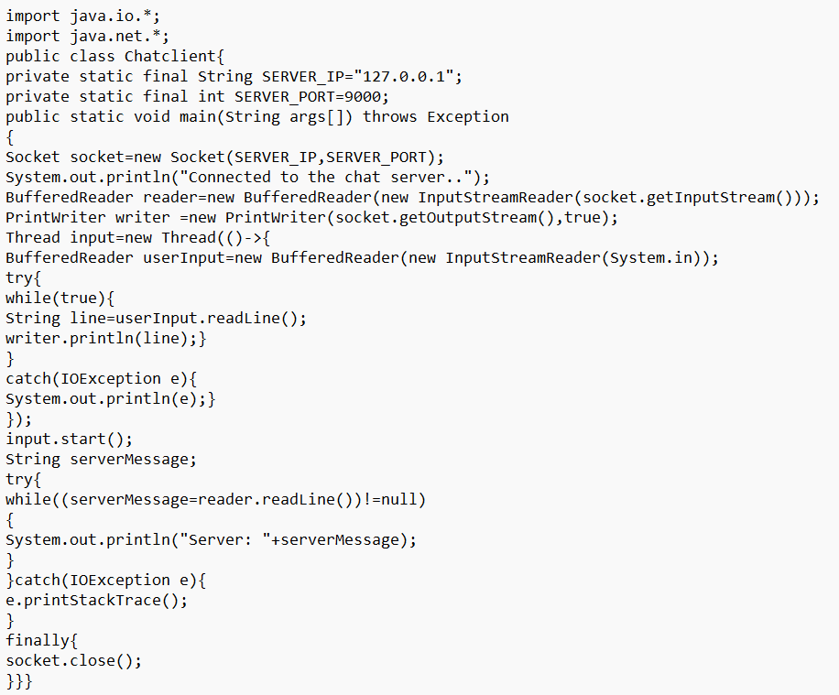

Output:

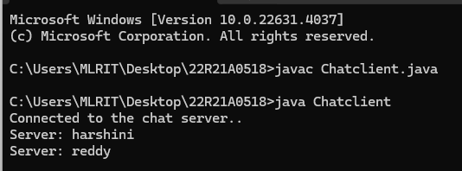

iiChatServer

Program:

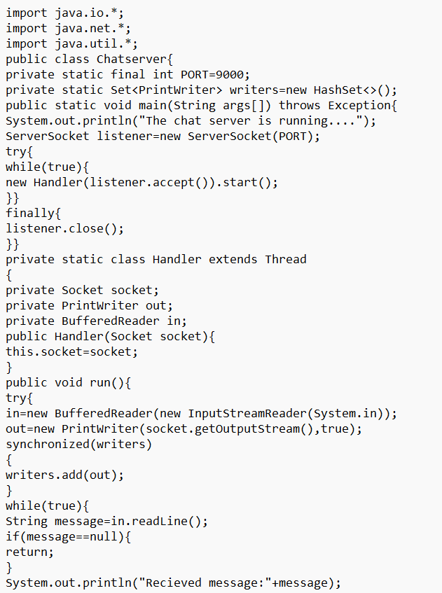

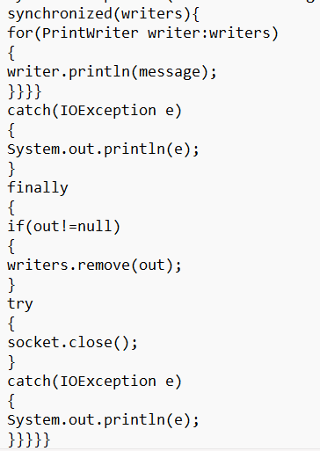

Output:

